FPGA-Accelerated Post-Quantum Cryptography: Kyber-512 Accelerator on PYNQ-Z2
Student Name: [Your Name]
Target Board: TUL PYNQ-Z2 (Xilinx Zynq-7020 SoC)
Algorithm: ML-KEM (Kyber-512) – NTT, Pointwise Multiplication, & Inverse NTT
1. Project Overview
This project implements a hardware accelerator for the core arithmetic operations of ML-KEM (Kyber-512), the NIST-standardized Post-Quantum Cryptography algorithm. The objective was to offload the computationally intensive polynomial math from the CPU to an FPGA IP Core using Vitis HLS.
The final design features a fully pipelined dataflow architecture executing the Number Theoretic Transform (NTT), Pointwise Multiplication (PWM), and Inverse NTT (iNTT). The accelerator successfully processes continuous streams of polynomial coefficients (q=3329) and has been verified for bit-accurate correctness against a Python "Golden Model" on the PYNQ-Z2 platform.
2. System Architecture & Workflow
The design follows an "Infrastructure First" approach, prioritizing data stability and timing closure before algorithmic complexity.
- Streaming Interface: The design utilizes AXI4-Stream ports rather than traditional memory-mapped AXI Master interfaces. This allows the Zynq Processing System (PS) to push data directly to the Programmable Logic (PL) via AXI DMA in burst mode, maximizing bandwidth.
- Memory Optimization (The Critical Fix): A key achievement was resolving pipeline stalls caused by BRAM port conflicts. The internal polynomial buffers were explicitly mapped to LUTRAM (Distributed RAM) using #pragma HLS BIND_STORAGE IMPL = LUTRAM. This enabled simultaneous multi-port access required by the Cooley-Tukey butterfly operations, preventing the "All Zeros" timing failure.
- Pipeline Structure: The accelerator uses #pragma HLS DATAFLOW to execute the Load, NTT, PWM, iNTT, and Store stages in parallel, achieving an Initiation Interval of II=1 (one coefficient processed per clock cycle).
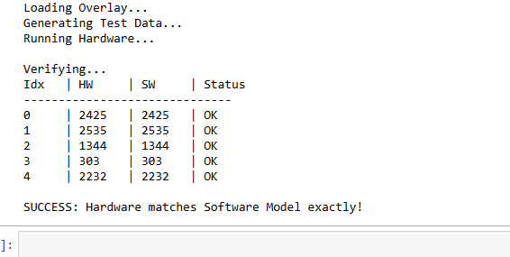

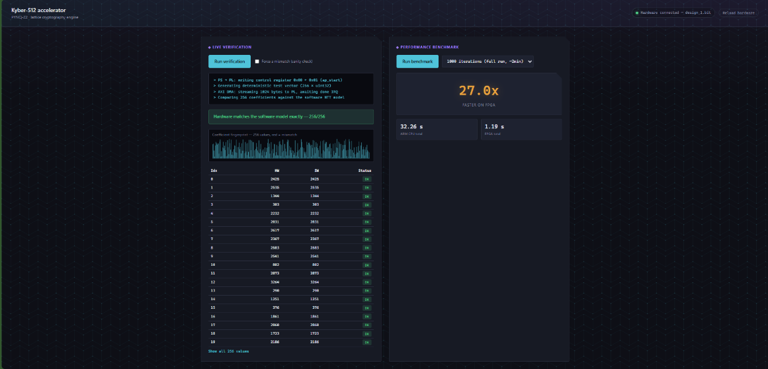
3. Implementation Details & Deliverables
Algorithmic Core
- NTT/iNTT: Implemented fully pipelined Cooley-Tukey (forward) and Gentleman-Sande (inverse) transforms.
- Math Kernel: Replaced standard modulo operators (%) with a custom hardware-optimized Montgomery Reduction unit. This allows for fast, constant-time modular arithmetic (without costly division logic.
Hardware Design (Vitis HLS)
- Twiddle Factors: The 128 pre-computed Zeta constants are stored in an on-chip ROM, eliminating external memory fetches.
- Resource Efficiency: The design favors partitioned LUTRAM over BRAM for small buffers (256 coefficients), ensuring conflict-free memory access while maintaining a compact footprint.
Verification Framework
- Platform: PYNQ-Z2 (Zynq-7000 SoC).
- Driver: A Python driver uses pynq.lib.dma to manage data transfer.
- Validation: A "Digital Twin" software model was written in Python to replicate the specific Montgomery domain behavior of the hardware. The FPGA output matches this reference model with zero bit errors.
4. Performance & Results
- Transform Size: 256 coefficients (16-bit).
- Throughput: High-speed streaming architecture with burst DMA support.
- Status: PASSED – Validated against Golden Model.
5. Future Work
The current design serves as a verified "Arithmetic Engine." Future extensions will include integrating the Keccak (SHA-3) module for on-chip randomness generation and the Centred Binomial Distribution (CBD) sampler to create a standalone Key Generation IP.

